**CS515 Advanced CS Practicum**

**Assignment Report of Lab 6: Virtual Networking**

Submitted By

Akash Pal(T23197)

Exercise 1:

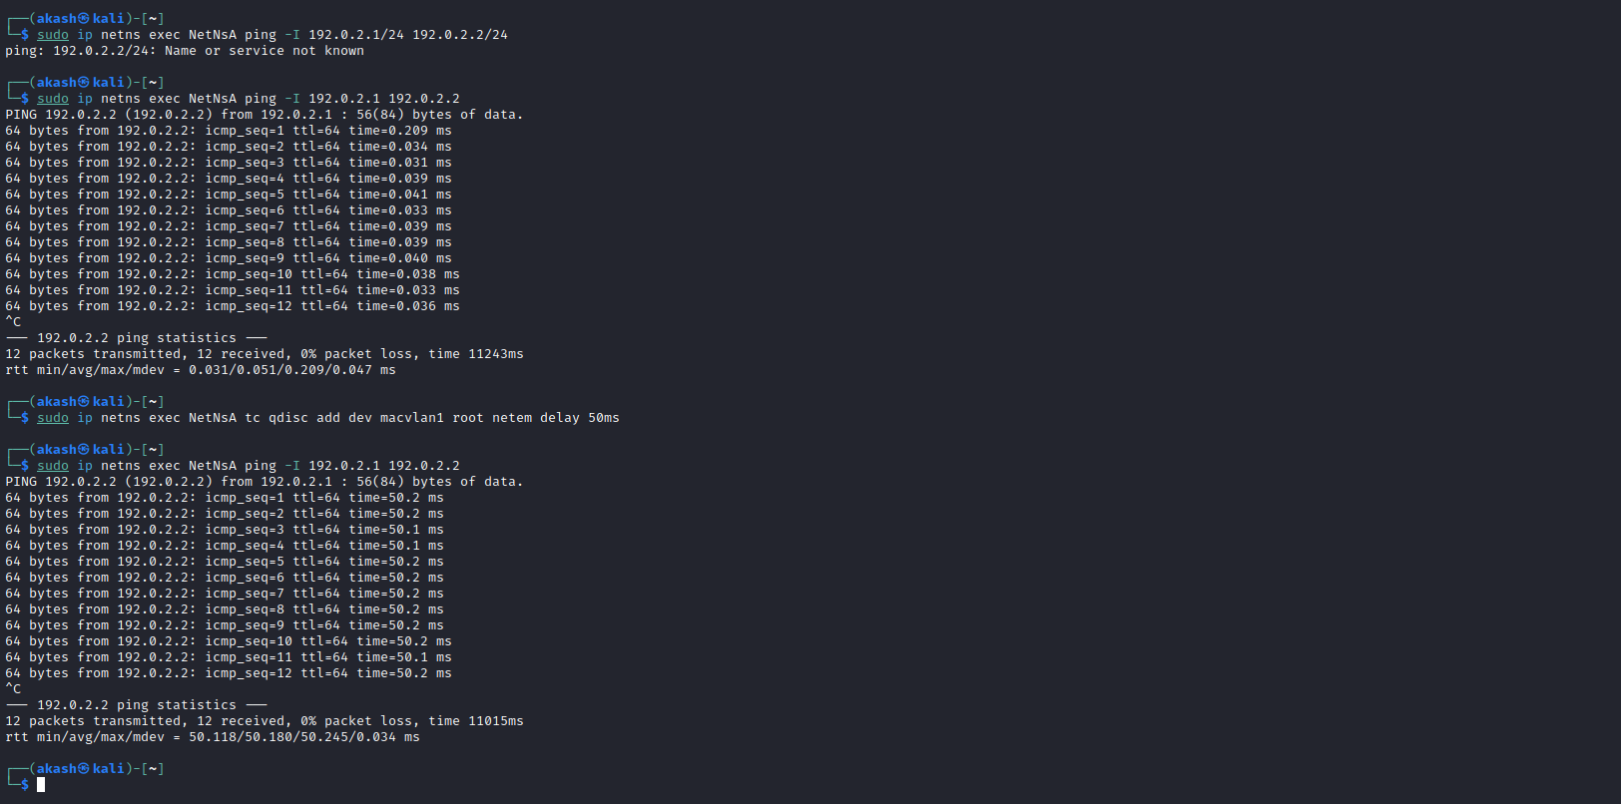Create two network namespaces, NetNsA and NetNsB. In each of these, create one network interface. Then we ping between them with no deley and a fixed delay of 50 ms. Result is shown in the following screenshot.

**Observation (From above Output):**

Task a (No Added Delay):

* The ping responses are quick and consistent, as there are no additional delays imposed on the network.
* Round-trip times (RTTs) between NetNsA and NetNsB would be relatively low and consistent.

Task b (Fixed Delay of 50ms):

* Adding a fixed delay of 50ms creates a consistent delay for each packet.
* The ping responses would show an additional delay of 50ms compared to Task a.
* RTTs are consistently higher than in Task a due to the fixed delay.

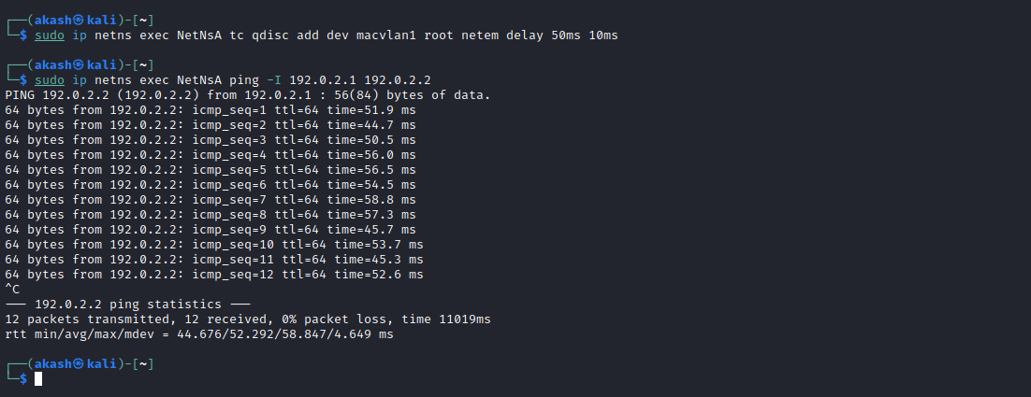

**Observation From Above Output Screenshot:**

Task c (Variable Delay of 50ms with 10ms Jitter):

* Adding a variable delay with jitter introduces fluctuations in the delay experienced by each packet.
* Ping responses would show varying delays around 50ms, with some packets experiencing delays as low as 44ms and some as high as 59ms.
* RTTs would vary, indicating a less predictable network performance compared to fixed delay but still higher than Task a.

Exercise 2:

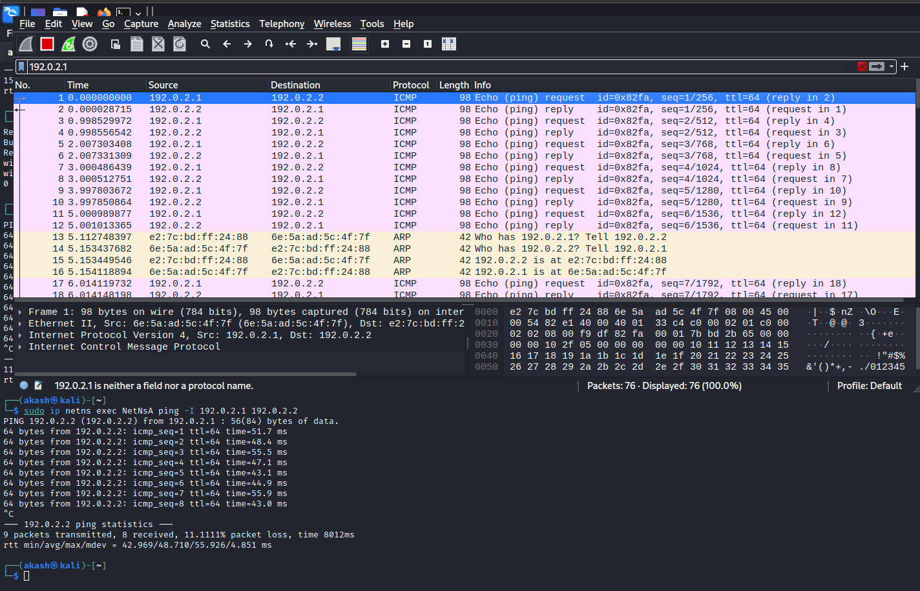

**Observation (From the above output screenshot):**

* While using Wireshark to capture packets between two network spaces (NetNsA and NetNsB) at the time of pinging, ICMP packets are being transmitted and received between the namespaces.
* ICMP echo request packets sent from the NetNsA(192.0.2.1) to the NetNsB(192.0.2.2). In response to the ICMP echo reply packets sent from NetNsB(192.0.2.2) back to NetNsA(192.0.2.1).
* ICMP Echo Request and Reply packets have sequence numbers. These sequence numbers help in tracking the order of packets and identifying any lost or out-of-order packets.
* It is also observed that Wireshark provides timestamps for each captured packet.
* While communication between two namespaces, some ARP request packets and ARP reply packets are also transmitted. These ARP packets are used to map the IP address to MAC address. ARP requests are broadcast packets while ARP replies are unicast packets.